Mediators between self-criticism and depression
Author*
Affiliatition
Address
*Corresponding Author. e-mail: author@.ac.id
Received: ...; Revised: ...; Accepted: ...

Abstract
The abstract firmly states the aim, method, and findings of the research. It is written narratively in a maximum of 250 words. Abstract abstract abstract abstract abstract abstract abstract abstract abstract abstract abstract abstract abstract abstract abstract abstract abstract abstract abstract abstract abstract abstract abstract abstract abstract abstract abstract abstract abstract
Keywords: keywords, keywords

This is an open-access article under the CC–BY-SA license.

Introduction

Introduction contains background, rationale, and/or the urgency of the research. Reference (literature or relevant research(es) need to be included in in this part; its relation to the justification of the research urgency; the emergence of research problems; alterna-tive solution; and the solutions which are chosen. In writing the citation in the text, the following elements should be presented clearly: the last name of the author; year of publication; and the page in which the cited text is located. For example: From the year 1990, vocational school is only available from senior secondary school or starts from grade 10 (Paryono, 2005, p.48). We strongly recommend the authors to use Reference Manager application in writing the citation and references list.
Problems, aims/objectives, and benefits of the research, and operational definition (if needed), are written narratively in paragraphs. There is no need to give them certain sub-titles/headings. Please notice that all text/words written in non-English languages must be written in italic form seperti tulisan ini.
Method
Method comprises the type of the research, time and setting/place of the research, the targets of the research, subjects of the research, procedure, instruments, data collection techniques, data analysis tech-niques, and also other things related to the research method. Heading and sub-headings are written in the following format:
Heading 1
Text running.......................................... ...............................................................................
Sub-heading1
Text running........................................... ....................................................................
Sub-heading2

Text running........................................... .................................................................................
If figures or tables need to be added, do not forget to write a figure number and caption below the figure, and a table number and title above the table.

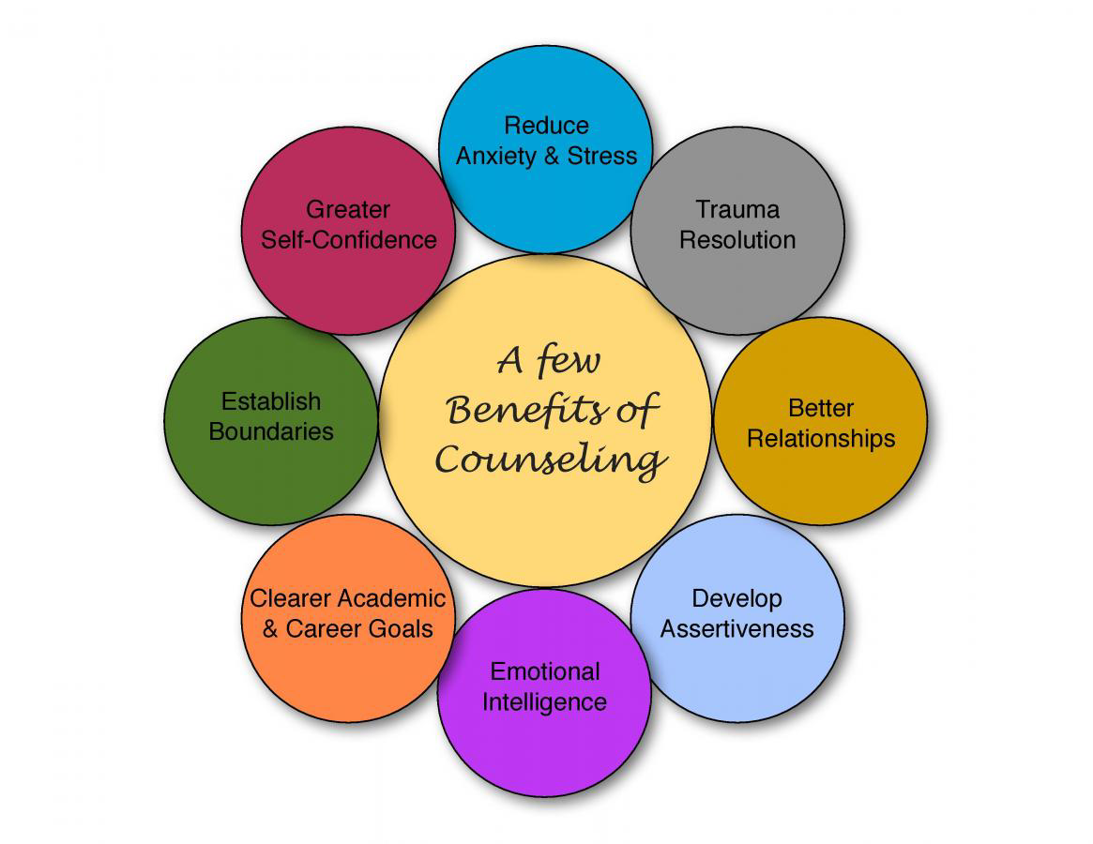
Figure 1. Bringing up style in the journal template

Findings and Discussion
The writing format must comply with the style provided in this template. The Style is shown in the Microsoft Word in Home tab and then Change Style sub-tab as shown in Figure 1. Style is used by putting the pointer to the text, then clicking on the appropriate Style. Table 1 is the list of the Style content and its function. Comments which appear in this template can be deleted by putting the pointer to the highlighted text, then choose Review tab and choose Delete.
Table 1. Style and its function
No | Style Name | Function
1 | ABSTRACT BODY | Abstract
2 | ABSTRACT KEYWORD | Keywords of the abstract
3 | AUTHOR | Author(s)
4 | AUTHOR IDENTITY | Author(s) Identity(es)
5 | BODYTEXT | Article text/paragraphs
6 | FIGURE | Figure caption
7 | HEADING 1 | Chapter (Bold)
8 | HEADING 2 | Sub-chapter (non-italic, non-bold)
9 | HEADING 3 | Sub-chapter (italic)
10 | QUOTES | Citation
11 | REFERENCES | References writing
12 | TABLE | Table caption
13 | TITLE | Article title
Conclusion (and implications, recommen-dations, or suggestions, if any)
Conclusion can be in the form of finding generalization according to the research problems, or recommendations for further steps. Meanwhile, suggestions can be in the form of input/proposition for future researchers, or implicative recommendations from the research findings.
Acknowledgment (if any)
In this section, the funding or grant-awarding bodies is acknowledged. For single agency grants: "This work was supported by the [Name of Funding Agency] under grant [number xxxx].

References
The citation and references are referred to American Psychological Association (APA) (Sixth Edition) style. The author is strongly recommended to use Reference Manager ap-plication (Mendeley) to facilitate referencing. The followings are the examples of reference style in various sources:
Books:
Hoy, W. K. & Miskel, C. G. (2008). Educational administration: Theory, research, and practice (8th ed.). New York, NY: McGraw-Hill International Edition.
Journals:
Retnawati, H., Munadi, S., & Al-Zuhdy, Y. A. (2015). Factor analysis to identify the dimension of Test of English Proficiency (TOEP) in the listening section. REiD (Research and Evaluation in Education), 1(1), 45–54. https://doi.org/ 10.21831/reid.v1i1.4897
Wang, C., & Gierl, M. J. (2011). Using the attribute hierarchy method to make diagnostic inferences about examinees’ cognitive skills in critical reading. Journal of Educational Measurement, 48(2), 165–187.
Book Review:
Dent-Read, C., & Zukow-Goldring, P. (2001). Is modeling knowing? [Review of the book Models of cognitive development, by K. Richardson]. American Journal of Psychology, 114, 126-133.
Online Newspaper Articles:
Becker, E. (2001, August 27). Prairie farmers reap conservation's rewards. The New York Times. Retrieved from http:// www.nytimes.com
Technical and Research Reports:
Hershey Foods Corporation. (2001, March 15). 2001 Annual Report. Retrieved from http://www.hersheysannualreport.com/2000/index.htm

